15/11/20
THM 415: Finance
Midterm Exam Answer Sheet

- “In limited partnership, general partners are liable up to the amount invested.” Do you agree with this statement? Why? Why not? (2 Points)
No, I don’t agree with this statement. For, since general partners run directly the business, they should face unlimited liability for firm’s debts.

- Aboubacar Hotel had recorded the following income statement accounts sorted in alphabetical order:

Cost of Goods Sold | $3,897,402
Interest Expenses | $758,630
Operating Expenses | $1,005,827
Sales | $6,275,805

In addition, since Aboubacar Hotel owns 48 % shares of Vincent Company, it is entitled to $ 1,903,000 of dividends income from that very company. Moreover, Aboubacar hotel’s board of directors decided to distribute $ 183,500 as dividends to their shareholders.
The following table reveals Income Tax Rates for Corporate Income for 2019 fiscal year:

Taxable Income | Marginal Tax Rate
$ 0 – $ 125,000 | 8%
$ 125,001 - $250,000 | 10%
$ 250,001 - $ 500,000 | 12%
$ 500,001 - $ 750,000 | 14%
$ 750,001 - $ 1,000,000 | 16%
$ 1,000,001 - $ 1,250,000 | 18%
Over $ 1,250,000 | 20%

Lastly, the following table shows dividend income exclusion to avoid double taxation at corporate level.
Ownership Interest | Dividend Exclusion
Less than 20 % | 15%
20 % to 35 % | 30%
35 % to 55 % | 45%
55 % to 75 % | 60%
75 % to 85 % | 75%
More than 85 % | 100%

a) Construct Aboubacar Hotel Income Statement for the year ended December 31st, 2019. (2 Points)
Moreover, the following is Aboubacar Hotel’s comparative balance sheet as of December 31st, 2018 and December 31st, 2019:
- Construct Aboubacar Hotel Statement of Cash Flow for the year ended December 31st, 2019. (3 Points)
- Calculate the Quality of Earnings. Interpret your result. (1 Point)
- Quality of Earnings = (Cash Flow from Operations) / (Net Income) = 604,359 / 359,327 = 168.19 %.
Thus, in 2019, Aboubacar Hotel’s cash flow from operations was 168.19 % of the firm’s reported net income.
- Calculate the Capital Acquisition Ratio. Interpret your result. (1 Point)
- Capital Acquisition Ratio = (Cash Flow from Operations) / (Cash Paid for Capital Expenditures) = 604,359 / 71,995 = 839.45 %.
Thus, in 2019, Aboubacar Hotel was able to finance 839.45 % of its new expenditures for plant and equipment out of the firm’s operation’s cash flow.
- Based on the income statement prepared in part a), comparative balance sheet and cash flow statement prepared in part b), analyze the financial situation of Aboubacar Hotel for the fiscal year 2019. (3 Points)
Income Statement:
- In 2019, Aboubacar hotel is a profitable company as its revenues (i.e. sales) are greater than its costs.
- In 2019, Aboubacar Hotel’s mark-up on its cost of goods sold is 37.90 %.
- In 2019, for each dollar of revenue, Aboubacar Hotel is left with 21.87 cents after deducting all its operating expenses.
- In 2019, each one dollar of sales is associated with 5.73 cents of net income.
Balance Sheet:
- Aboubacar hotel is a highly liquid company as its net working capital is $ 2,358,522. This means that current assets can shrink by as much as $ 2,358,522 and the company would still be able to pay its current liabilities.
- In Aboubacar Hotel, the purchases of assets are financed 35.52 % through debt and 64.48 % through equity.
- For each one dollar of net income, 48.93 cents are retained in the business.
Statement of Cash Flow:
Cash flow from operating activities:
- Aboubacar Hotel has positive cash flows from operating activities.
- The primary contributors to the operating cash flows were net income and inventory.
- Other current assets are the only contributor of cash usage.
Cash flow from investing activities:
- Aboubacar Hotel invested $ 71,995 in purchasing fixed assets. This is roughly 11.91 % of the total cash flow generated from operations.
Cash flow from financing activities:
- Aboubacar Hotel has negative cash flows from financing activities.
- All cash outflow went as payment of already declared dividends, purchase of marketable securities and payment of long-term notes.
- Cash inflow is generated from short-term debt, issuance common stock (par value) as well as from common stock (paid-in-capital).
- Suppose you would like to quadruple your investment. For this purpose, you deposited in a bank $ 14,877.03 to be compounded monthly at an interest rate of 5.06 %. Calculate the period (in years) needed to reach your objective? (1 Point)
- Interest Rate = 5.06 % / 12 ≈ 0.4217%; Present Value = - $ 14,877.03; Payment = $0; Future Value = $ 59,508.12.
Answer: Nper (0.4217%, 0, -14877.03, 59508.12) / 12 = 27.45 Years.
Therefore, it would take 27.45 years for an investment of $ 14,877.03 to quadruple at an annual interest rate of 5.06 % compounded monthly.
- After examining the various interest rates opportunities, you find that you can invest in a finance company at 12.43 % compounded quarterly, in bank A at 12.26 % compounded weekly.
a) Which alternative is the most attractive? Why? (1 Point)
- Investing in Finance Company: Effective Annual Rate = Effect (12.43 %, 4) = 13.02 %.
- Investing in bank A: Effective Annual Rate = Effect (12.26 %, 52) = 13.03 %.
→ Since I am investing, I shall choose the offer that has the highest Effective Annual Rate. Therefore, I shall invest in Bank A.
b) If you wanted to consider Bank B which offers continuous compounding. What is the minimum interest rate suggested by this very bank to start thinking about the offer? (1 Point)
The minimum interest rate suggested by Bank B shall be 12.25 %.
- N’Sakala wanted to buy a home that costs $ 612,500. He took a 10-year mortgage loan with semi-annual payments at an annual rate of 5.42 %.
a) How much will N’Sakala pay each period? (1 Point)
Interest = 5.42 % / 2 = 2.71 %, Period = 10 * 2 = 20; Present Value = $ 612,500; Future Value = $ 0
Answer: PMT (2.71 %, 20, 612500, 0) = - $ 40,073.72.
b) Fill in the amortization schedule. (3 Points)
Period | Amount Owed on the Principal (Beg. Period) ($) | Annuity Payment ($) | Interest Portion of the Annuity ($) | Repayment of the Principal Portion of the Annuity ($) | Outstanding Loan Balance ($)
1 | $612,500.00 | $40,073.72 | $16,598.75 | $23,474.97 | $589,025.03
2 | $589,025.03 | $40,073.72 | $15,962.58 | $24,111.15 | $564,913.88
3 | $564,913.88 | $40,073.72 | $15,309.17 | $24,764.56 | $540,149.32
4 | $540,149.32 | $40,073.72 | $14,638.05 | $25,435.68 | $514,713.65
5 | $514,713.65 | $40,073.72 | $13,948.74 | $26,124.98 | $488,588.66
6 | $488,588.66 | $40,073.72 | $13,240.75 | $26,832.97 | $461,755.69
7 | $461,755.69 | $40,073.72 | $12,513.58 | $27,560.14 | $434,195.55
8 | $434,195.55 | $40,073.72 | $11,766.70 | $28,307.02 | $405,888.52
9 | $405,888.52 | $40,073.72 | $10,999.58 | $29,074.14 | $376,814.38
10 | $376,814.38 | $40,073.72 | $10,211.67 | $29,862.05 | $346,952.32
11 | $346,952.32 | $40,073.72 | $9,402.41 | $30,671.32 | $316,281.01
12 | $316,281.01 | $40,073.72 | $8,571.22 | $31,502.51 | $284,778.50
13 | $284,778.50 | $40,073.72 | $7,717.50 | $32,356.23 | $252,422.27
14 | $252,422.27 | $40,073.72 | $6,840.64 | $33,233.08 | $219,189.19
15 | $219,189.19 | $40,073.72 | $5,940.03 | $34,133.70 | $185,055.49
16 | $185,055.49 | $40,073.72 | $5,015.00 | $35,058.72 | $149,996.78
17 | $149,996.78 | $40,073.72 | $4,064.91 | $36,008.81 | $113,987.96
18 | $113,987.96 | $40,073.72 | $3,089.07 | $36,984.65 | $77,003.31
19 | $77,003.31 | $40,073.72 | $2,086.79 | $37,986.93 | $39,016.38
20 | $39,016.38 | $40,073.72 | $1,057.34 | $39,016.38 | ($0.00)
c) Suppose that exactly after 4 years, mortgage interest rates fell to 5.03 %. If N’Sakala has the chance to refinance his loan at that very interest, how much would he pay (on a semi-annual basis) for the remaining 6 years of the loan? (1 Point)
Interest = 5.03 % / 2 = 2.515 %, Period = 6 * 2 = 12; Present Value = $ 405,888.52; Future Value = $ 0
Answer: PMT (2.515 %, 12, 405888.52, 0) = - $ 39,604.85.
d) If such a refinance opportunity is associated with paying a prepayment penalty fee to the bank of $ 5,250, shall N’Sakala refinance his loan? Why? Why not? (2 Points)
The answer to this question lies in coming up with cash flow increments by taking the difference of cash flows (for each of the remaining 6 years) between the first scenario (i.e. continuing paying $ 40,073.72) and second scenario (i.e. paying $ 5,250 as a penalty in year 0, and saving $ 468.87 for the remaining 12 six-month periods). To sum up, the following table reveals the cash flow increments from opting for the second scenario:
As can be seen from the above table, paying $ 5,250 as a pre-payment penalty but start saving $ 468.87 for the remaining 12 six-month periods (i.e. 40,073.72 – 39,604.85) would yield a negative return. Hence, N’Sakala should NOT re-finance the mortgage loan since he will be worse off in the second scenario.
- Upon evaluation of the distribution of returns of Larin company, the following possible rate of returns for the upcoming period as long as their probability of occurrence are estimated:
Probability of Occurrence | Rate of Return on Investment
7% | -9.03%
9% | -5.23%
11% | -1.74%
15% | 0.99%
19% | 5.16%
23% | 9.88%
16% | 11.05%
a) Calculate the Expected Rate of Return of Larin Company stock. (1 Point)
- Expected Rate of Return = (7 % * - 9.03 %) + (9 % * - 5.23 %) + (11 % * - 1.74 %) + (15 % * 0.99 %) + (19 % * 5.16 %) + (23 % * 9.88 %) + (16 % * 11.05 %) = 3.88 %.
b) What is the risk of the investment in Larin Company stock as measured using the standard deviation of possible future rates of return? (2 Points)
- Gökhan bought some stocks of Töre Company worth of 1,250,000 Euros 8 years ago. Following is the beginning value of Töre bought stocks 8 years ago as well as the values at the end of each year up until today (the end of year 8):
Year | Annual Rate of Return | Stock Value (Euros)
0 |  | 1,250,000.00
1 | -4.02% | 1,199,750.00
2 | -3.14% | 1,162,077.85
3 | 6.24% | 1,234,591.51
4 | 8.77% | 1,342,865.18
5 | 3.56% | 1,390,671.18
6 | 8.23% | 1,505,123.42
7 | 7.56% | 1,618,910.75
8 | -1.03% | 1,602,235.97
a) What will be the annual rate of return that Gökhan expects to earn next year, if he plans to continue holding Töre Company stocks? (1 Point)
- Annual rate of return that Gökhan expects to earn next year, if he plans to continue holding Töre Company stocks = (- 4.02 % - 3.14 % + 6.24 % + 8.77 % + 3.56 % + 8.23 % + 7.56 % - 1.03 %) / 8 = 3.27 %.
b) What annual rate of return that Gökhan expects over a five-year horizon from holding Töre Company stocks? (1 Point)
- Annual rate of return that Gökhan expects over a five-year horizon from holding Töre Company stocks = ((1 + 8.77%) * (1 + 3.56%) * (1 + 8.23%) * (1 + 7.56%) * (1 - 1.03%))^^{(1/5)} – 1 = 5.35%.
- You own a portfolio consisting of the following stocks:

Assume the risk-free rate is 4.75 % and the expected return on the market portfolio is 15.30 %.
- Calculate the expected return of your portfolio. (0.50 Points)
- Expected return (Portfolio) = (25 % * 17 %) + (15 % * 15%) + (20% * 21%) + (23 % * 13 %) + (17 % * 21 %) = 17.26 %.
- Calculate the portfolio beta. (0.50 Points)
- Beta (Portfolio) = (25 % * 0.93) + (15 % * 0.72) + (20% * 1.26) + (23 % * 0.54) + (17 % * 1.57) = 0.98.
- Plot the security market line on a graph. (2 Points)
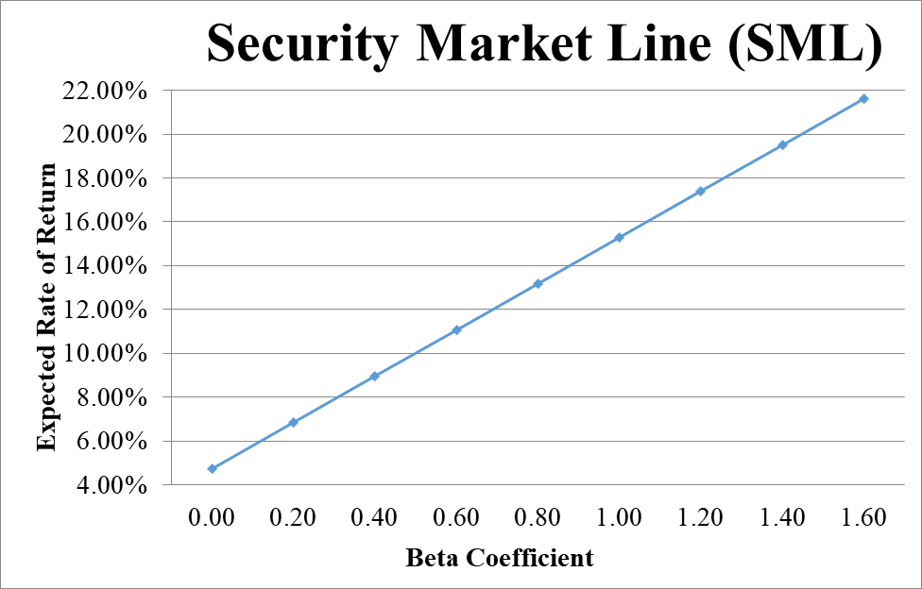
- From your plot in part c, which stocks appear to be your winners, and which ones appear to be losers? Explain the reason behind your conclusion. (2 Points)
Therefore, except stock 5, all the other stocks are all offering higher expected returns than they should be, given their systematic risks. Thus, except stock 5, they are all underpriced. That’s why our portfolio’s expected return was higher than what was justified, given its beta. We have found four underpriced stocks☺
- Why should you consider your conclusion in part d) to be less than certain? (1 Point)
This conclusion is based on our having the right betas. Recall that calculation of Betas are subjective (i.e. depend on the market to be chosen, sample size, time interval chosen, definition of period…). If all of our betas understate their stock’s systematic risks, then we would be underestimating our portfolio risk.
GOOD LUCK!

